PRESONAL PROFILE

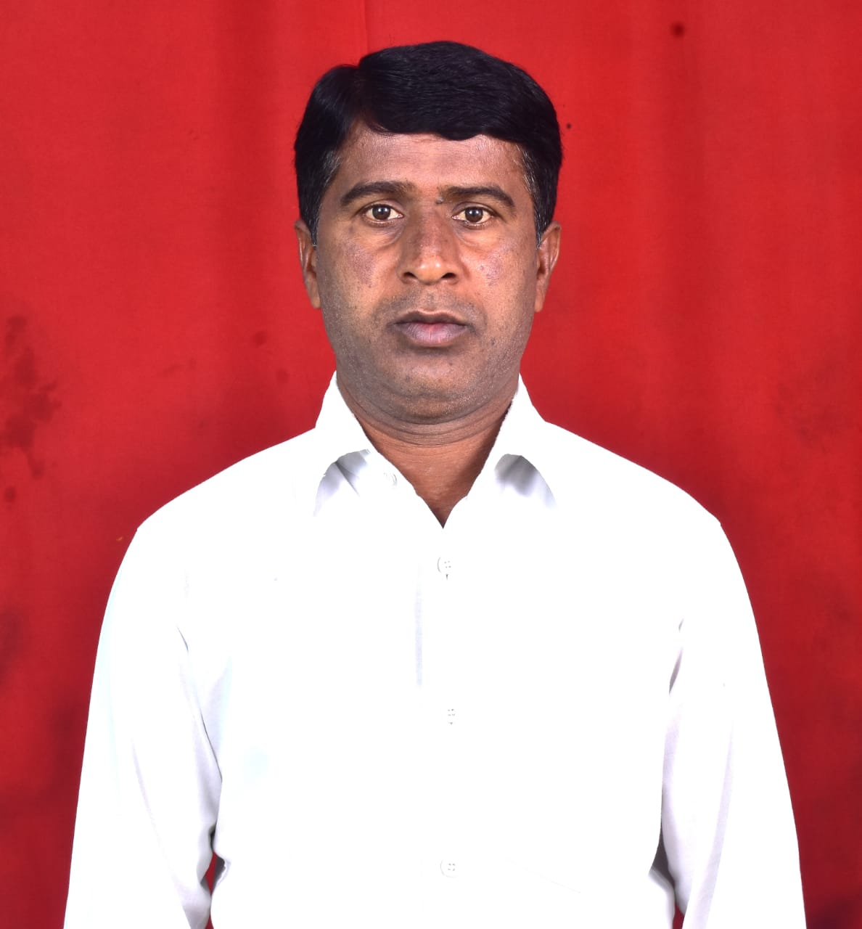

Attach photo
C.DODDANAGAPPA _{M.Sc., M.Phil., (Ph.D)}
Lecturer in PHYSICS,
K.T.S. Government College,
RAYADURG, Anantapur District, Andhra Pradesh,
Mobile: 9491833803
Email: ashanag9@gmail.com
__________________________________________________________________________

- Academic Qualifications and Other details:
Subject : PHYSICS
Highest Educational Qualification : M.Sc., M.Phil.,
Employee ID : ashanag9@gmail.com
Date of Birth :15/06/1978
Social Category : ST/SC/BC-A /B/C/D/OC
Religion : HINDHU
Gender : MALE
- Date of Joining service as :
- Lecturer in Degree College : 27/09/2004
- In K.T.S. College, Rayadurg :19/10/2021
3. Educational Details:

S.NO | CLASS | Board/University | YEAR | Division | % of marks
1 | SSC | Secondary School Education | 1994 | Second | 57.33%
2 | INTER | Pre-University Education | 1996 | Second | 58.45%
3 | UG | Bangalore University | 2000 | Second | 54%
4 | PG | Bangalore University | 2004 | Second | 57.55%
5 | B.Ed | S.K University | 2010 | First | 65%

4.Previous Professional (Teaching) Experience :

S.No | Institution | From | To | Designation | No.of Years
1 | G.D.C. MADAKASIRA | 2004 | 2010 | Lecturer | 08
2 | G.D.C. KALYANDURG | 2011 | 2015 | Lecturer | 05
3 | G.D.C. MADAKASIRA | 2015 | 2019 | Lecturer | 05
4 | G.D.C. GUNTAKAL | 2020 | 2021 | Lecturer | 01
5 | G.D.C. RAYADURG | 2021 | Till date | Lecturer | 03

5.National / International seminars or Work Shops/Trainings attended :

S.No | National/ International | Institution/place | Date | Title of the paper Presented
1 | National Seminar | G.D.C. Kalyandurg | 09&10  2011 | Green Chemistry
2 | National Seminar | G.D.C. Kalyandurg | 17&18  2012 | Frontiers of Material Science
3 | National Seminar | G.D.C. Kalyandurg | 22&23  2013 | e-governance
4 | National Seminar | G.D.C. Kalyandurg | 09&10  2014 | Necessity of inter personal Relations for Human Excellence
5 | National Symposium | G.D.C. Kalyandurg | 10.12  2014 | Human Rights Education

6. Any other Curricular/Co curricular/Extracurricular Activities involved:

- NSS Program Officer
- Audio visual
- Students Grievance Cell

